REBEL Cast April 2015 Show Notes

Topic #1: Basic Life Support (BLS) vs Advanced Cardiac Life Support (ACLS) in Out of Hospital Cardiac Arrest (OHCA)

Question: Does Advanced Cardiac Life Support (ACLS) or Basic Life Support (BLS) have larger beneficial effects on outcomes for Out of Hospital Cardiac Arrest (OHCA)?

What Specific Article Will We Be Covering?

Saghavi P et al. Outcomes After Out-of-Hospital Cardiac Arrest Treated by Basic vs Advanced Life Support. JAMA Intern Med 2015; 175 (2): 196 – 204. PMID: 25419698

Details of the Study

Study Type: Observational Cohort Study

Population: Medicare beneficiaries from non-rural counties who experienced out-of-hospital cardiac arrest (31,292 ACLS Cases and 1643 BLS Cases)
Intervention: ACLS
Control: BLS
Outcome: Survival to hospital discharge, 30 days, and 90 days; Neurological performance

Results:
- Survival to Hospital Discharge: BLS > ACLS (13.1 vs 9.2%)
- Survival to 30 days: BLS > ACLS (9.6 vs 6.2%)
- Survival to 90 days: BLS > ACLS (8.0 vs 5.4%)
- Poor Neurologic Functioning: BLS < ACLS (6.1 vs 9.7%)
- Better Neurologic Functioning of Patients Hospitalized: BLS > ACLS (78.2 vs 55.2%)

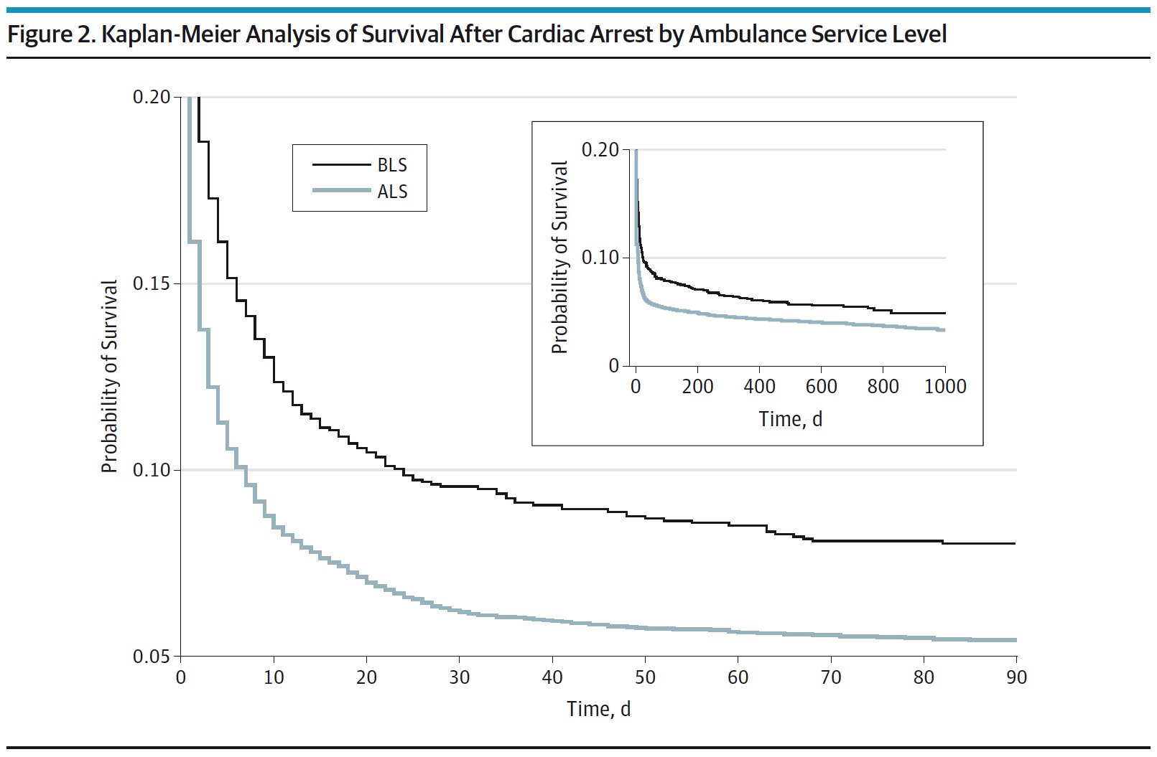

Limitations:
- Observational Analysis, but unlikely a randomized clinical trial will occur comparing ACLS vs BLS
- Patients receiving ACLS may have a higher risk of mortality irrespective of interventions
- Ambulance response times and shockable rhythms were not followed in this study
- CPR quality not evaluated or documented in this study
- Service level of ambulance (ACLS vs BLS) was abstracted from administrative coding fees.
- Older patient population: mean age for BLS = 77 and mean age for ACLS = 75

Discussion:

- This is the largest analysis of ACLS vs BLS in the United States
- Issues with ACLS in Pre-Hospital OHCA
- Pre-Hospital endotracheal intubation entails risks (i.e. esophageal intubation, aspiration, aggravation of existing c-spine injuries, and most importantly interruption with chest compressions). Bag Valve Mask Ventilation may improve outcomes over endotracheal intubation in OHCA
- Evidence on benefits of IV drug therapy in OHCA is limited
- Time spent on ACLS in the pre-hospital setting delays hospital care where there is more man power and more definitive treatments (i.e. Cardiac Catheterization)
- ACLS adds interventions that have not been shown to benefit (intubation, IV access, drug administration) and may distract from known beneficial interventions (High-quality CPR, defibrillation).

What is the clinical bottom line for the above clinical question?
Patients with OHCA who receive BLS have a higher survival to hospital discharge, survival to 90days, and more have better neurologic functioning vs patients who receive ACLS

For More on the Above Topic:

- Ken Milne at The Skeptics Guide to Emergency Medicine: SGEM #64 – Classic EM Papers (OPALS Study)

Topic #2: PROMISE Trial: Anatomic vs Functional Testing for Coronary Artery Disease (CAD)

Clinical Question: Does anatomic testing with coronary computed tomographic angiography (CCTA) result in improved health outcomes over functional testing in symptomatic patients with suspected CAD?

Article: Douglas PS et al. Outcomes of Anatomic versus Functional Testing for Coronary Artery Disease. NEJM 2015 [epub ahead of print] PMID: 25773919

Background: Chest pain is a common chief complaint seen in the emergency department (ED). Many of these patients are considered low risk and discharged home for outpatient testing, or they get admitted and have risk stratification testing done in the hospital. Stress testing is the most common method of evaluating for coronary artery disease with approximately 4 million stress tests performed annually in the United States.
Recently, the development of CCTA has shown potential to improve outcomes and reduce invasive testing due to its higher accuracy compared to functional testing. The impact of noninvasive anatomical testing versus functional testing on subsequent management and clinical outcomes is not known at this time.
The Prospective Multicenter Imaging Study for Evaluation of Chest Pain (PROMISE) trial sought to compare health outcomes between the two testing strategies.

What they did:
- Pragmatic comparative effectiveness design
- Patients randomized to anatomic (i.e. CCTA) or functional testing (i.e. Nuclear stress test, stress echocardiography, or exercise electrocardiography)
- Primary outcome: Composite of major cardiovascular events (Death from any cause, myocardial infarction (MI), hospitalization for unstable angina, major complication of cardiovascular procedures or diagnostic testing occurring within 72 hours).
  - Major complications = Stroke, major bleeding, renal failure, or anaphylaxis
- Secondary outcome: Composite of primary end point or invasive catheterization showing no obstructive CAD, cumulative radiation exposure at 90 days

Results:
- 10,003 patients included in the study
- 3.3 % (164/4996) of CCTA group and 3.0% (151/5007) of the functional group had primary end point at 2 years. (P=0.75)
- 3.4% of CCTA group had catheterization showing no obstructive CAD compared to 4.3% in the functional study group. (P=0.02)
- More patients in the CCTA group underwent catheterization within 90 days after randomization (12.2 vs 8.1%)
- More patients in the CCTA group underwent revascularization within 90 days after randomization (6.2 vs 3.2%)
- While the median exposure to radiation was lower in the CCTA group, cumulative exposure was higher in the CCTA group (12.0 mSv vs 10.1 mSv). (P<0.001)

Strengths:
- Large study population of 193 study sites in North America (10,003 patients)
- Majority of study sites were community based and not academic institutions which allows for generalizability of practice
- Two year follow up for outcomes for majority of patients (Follow-up truncated near end of study due to budgetary constraints.)

Weaknesses:
- No comparison statistics between the two groups. Are they similar?
- The use of a composite end-point for the primary outcome and despite the use of a composite endpoint there is low event rate of 3.1%
- Approximately 6% in each group underwent a different first test than what they were randomized. (i.e., randomized to CCTA, but underwent stress echocardiography)
- Heterogeneity of radiation exposure in functional testing group: 2 tests did not involve radiation, while one did (although nuclear stress was the most common functional test performed)

Clinical Bottom Line: Initial strategy of using CCTA for noninvasive testing in symptomatic patients with suspected CAD was not associated with better clinical outcomes compared to functional testing over median follow-up of two years. It was, however, associated with higher radiation exposure and downstream testing.

