August 2014 REBELCast Shownotes

Topic #1: Significance of Isolated Vomiting in Pediatric Minor Head Trauma

Clinical Question: What is the risk of significant intracranial injury in pediatric patients who present with minor head trauma and isolated vomiting?

OR: Do I need to get a NCHCT on all pediatric patients with minor head trauma and isolated vomiting or can I observe these patients without imaging and not risk missing significant intracranial injuries?

Article
Daya PS et al. Association of Traumatic Brain Injuries with Vomiting in Children with Blunt Head Trauma. Ann EM 2014; 63: 657-65.

Background: Blunt head trauma in kids is common. There are about 450,000 ED visits every year in the US alone for this complaint. We also know that kids vomit for every minor insult. If my kid coughs too hard, he’s likely to vomit. So take a kid who bonks his head and starts screaming and crying and vomiting is likely to ensue. Because of the penchant for kids to vomit with minor trauma, there’s a lot of controversy around whether imaging should be obtained on all peds head trauma with vomiting. A number of prediction rules for significant traumatic brain injury include vomiting in their criteria. However, we would like to avoid NCHCT for these kids if safe. There’s the exposure to radiation as well as the risks (although minor) associated with procedural sedation in those kids that need it to get the CT.

What is Isolated Vomiting?

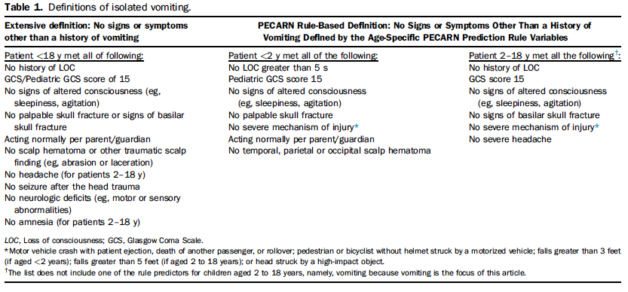

Details
- Study was a secondary analysis of a multicenter study from the PECARN group (for those who don’t know about the PECARN group they do a ton of high-quality research on pediatric issues)
- Compared pediatric patients with minor head injuries who had isolated vomiting with those that did not have vomiting.
- 2 out of 815 patients with minor head injury and isolated vomiting had clinically important traumatic brain injuries. (0.2% CI 0.0% to 0.9%) and 5/298 who had CTs had any TBI (1.7% CI 0.5 – 3.9)
- 114 out of 4577 patients with minor head trauma and non-isolated vomiting had a significant intracranial injury rate of 2.5%.
- Also found that 0 out of 6396 patients with minor head injury, no vomiting and no other clinical findings had clinically significant intracranial injuries.

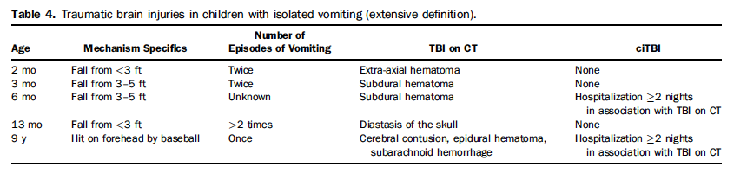

Weaknesses
- Secondary analysis of a database from PECARN
- Not all patients with isolated vomiting had CTs – only 298 of them did which means there may have been some selection biases on the part of the MDs.
- Lost 17.8% of patients to follow up

Clinical Bottom Line: Pediatric patients with minor head trauma and isolated vomiting are at an extremely low risk for clinically significant traumatic brain injury. It may be reasonable to manage these patients with ED observation followed by home observation instead of with immediate CT scan of the head.

Topic #2: Early Detection of Systemic Inflammatory Response Syndrome (SIRS) in the Emergency Department

Clinical Question: What percentage of patients presenting to the emergency department with SIRS, actually have an infectious etiology?

Article:
Horeczko, T et al. Epidemiology of the Systemic Inflammatory Response Syndrome (SIRS) in the Emergency Department. West J Emerg Med 2014; 15 (3): 329 – 336.

PMID: 24868313

Background: It is well known that the early recognition of sepsis will improve our ability to make early bedside detection of disease possible, and allow early therapeutic interventions to decrease morbidity and mortality. In a further effort to emphasize this large healthcare systems, international task forces as well as the Joint Commission, currently recommend sepsis screening for adults with systemic inflammatory response syndrome (SIRS) at triage, but the epidemiology of SIRS among adult emergency department patients is not well understood, as SIRS is the physiologic response to a variety of acute insults such as trauma, ischemia, hemorrhage, immune-mediated organ injury, and infectious etiologies.

Previous epidemiologic studies of SIRS have studied admitted patients with sepsis and severe sepsis, without considering patients not admitted with undifferentiated causes of SIRS and are mostly single center studies.

What they did:

- Retrospective analysis of ED visits by adults reviewing the National Hospital Ambulatory Medical Care Survey (NHAMCS)
- 103,701 raw patient encounters to estimate 372,844,465 ED visits over a 4-year period
- Patients on Beta Blockers or Calcium Channel Blockers were excluded from the analysis
- Categorized patients into minimum, moderate, and maximum estimates:
  - All patients met at least two criteria for SIRS (i.e abnormal temperature (>38 C or <36 C, pulse > 90 beats/min, or respiratory rate > 20 breaths/min) AND…
  - Minimum estimate: Assumed that WBC count ordered did not meet SIRS definition
  - Moderate estimate: Assumed that patients with WBC count ordered, half did and half did not meet SIRS definition
  - Maximum estimate: Assumed all WBC counts ordered did meet SIRS definition

Results:
- Moderate estimate of SIRS in the ED was 17.8% or a national estimate of approximately 16.6 million adult ED visits with SIRS/year
- If diagnosed with SIRS more likely to be:
  - Triaged as emergent (17.7% vs 9.9%)
  - Arrive by EMS (29.5% vs 17.1%)
  - Longer length of stay in ED (210 min vs 153 min)
  - Admitted (31.5% vs 12.5%)
  - Admitted to ICU vs regular hospital bed (11.2% vs 3.7%)
- Infection accounted for 26% of SIRS patients with the rest of the patients shown in the graph below:

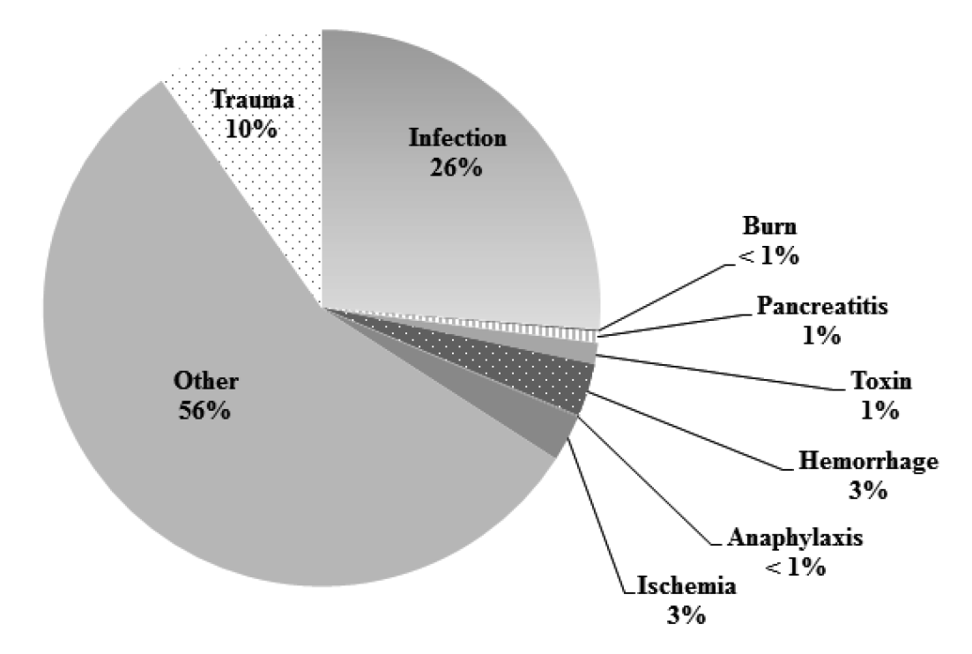

Limitations:
- NHAMCS represents ED visits and not individual, unique patients which do not follow classic textbook teaching
- Vital signs used from the NHAMCS database are limited to those measured at triage. Clinical picture can change throughout an ED visit, and use of triage vital signs and parameters to qualify patients for SIRS, can affect diagnosis, and disposition, instead of relying on history, physical exam, and supplemental testing as well
- Patients who did not have a WBC count ordered were assumed to not have an elevated WBC, potentially underestimating the true incidence of SIRS, while patients who did have WBC count ordered, 50% were assumed to have an abnormal test result which could overestimate the incidence of SIRS

Conclusion: SIRS is very common in the ED and infectious etiologies make up only a quarter of adult SIRS cases.

Comments:
- SIRS is common in the ED setting, but represents a heterogeneous group of patients, with only about a quarter associated with infection, and >60% of patients being discharged home. This means that SIRS lacks specificity of and the biggest concern with this is regarding increased utilization of resources.
- SIRS may have some utility in risk stratification of adult patients at ED triage, but screening millions of undifferentiated patients annually for severe sepsis may add unnecessary healthcare costs, length of ED stay, and exposure to additional invasive testing and antibiotics without clinician judgment.

Clinical Take Home Point: SIRS may have value as an early screening test (fairly sensitive) for identifying patients with higher rates of hospitalization, need for critical care, and short-term mortality, but without the combination of clinician judgment, alone is not useful as a diagnostic tool for infection (poorly specific).

